MC900352710[1]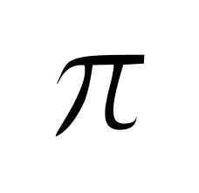

Social-Emotional

Literacy

**Based on Teaching Strategies GOLD, a standard assessment system aligned with the Common Core State Standards**

Widely Held Expectations for Entry to Kindergarten